**Project 2 Report**

**Name: Xianhe Zhang**

**Email:** [**zhang.xianh@northeastern.edu**](mailto:zhang.xianh@northeastern.edu)

**Description**

As described in the project requirements, this project is mainly used for image pairing. First, we will use different methods to calculate features, including baseline, histogram, multi-histogram, texture, and HSV. Then we will use different distance formulas to calculate the distances of different features to determine whether the images match. For different pictures, our distances are different. The closer the pictures are, the more similar they are.

**Baseline Matching**

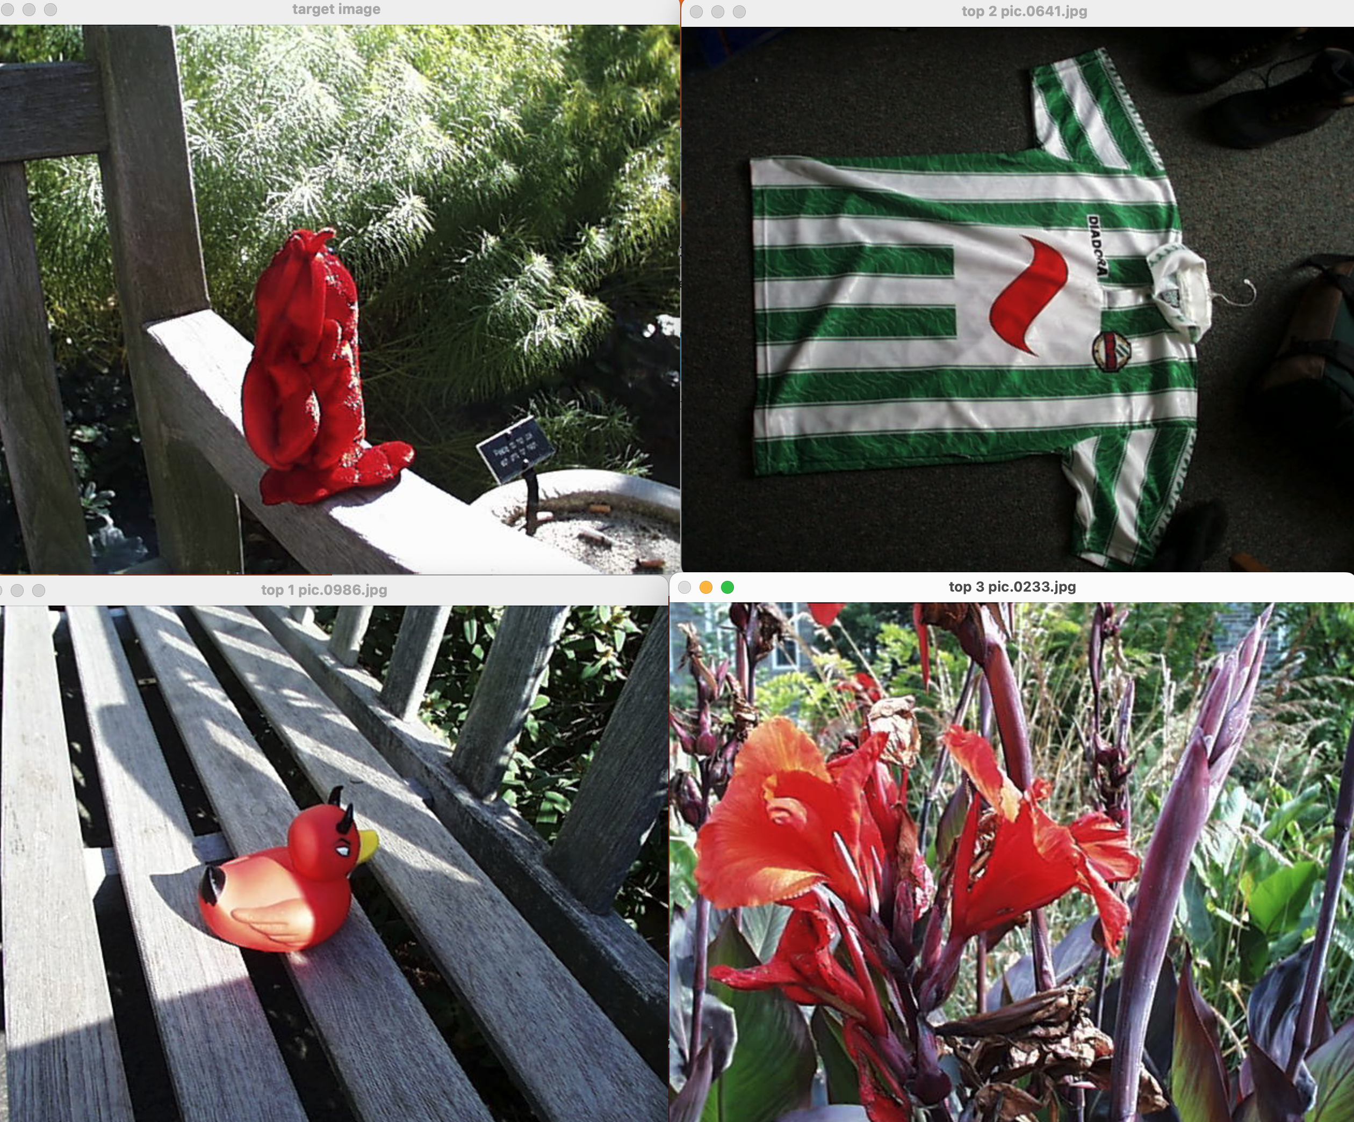

The above images are required result1. Based on “Use the 9x9 square in the middle of the image as a feature vector. Use sum-of-squared-difference as the distance metric. ”

**Histogram Matching**

These results for query pic.0164 were obtained with a whole image RGB histogram using 8 bins for each of RGB and histogram intersection as the distance metric.

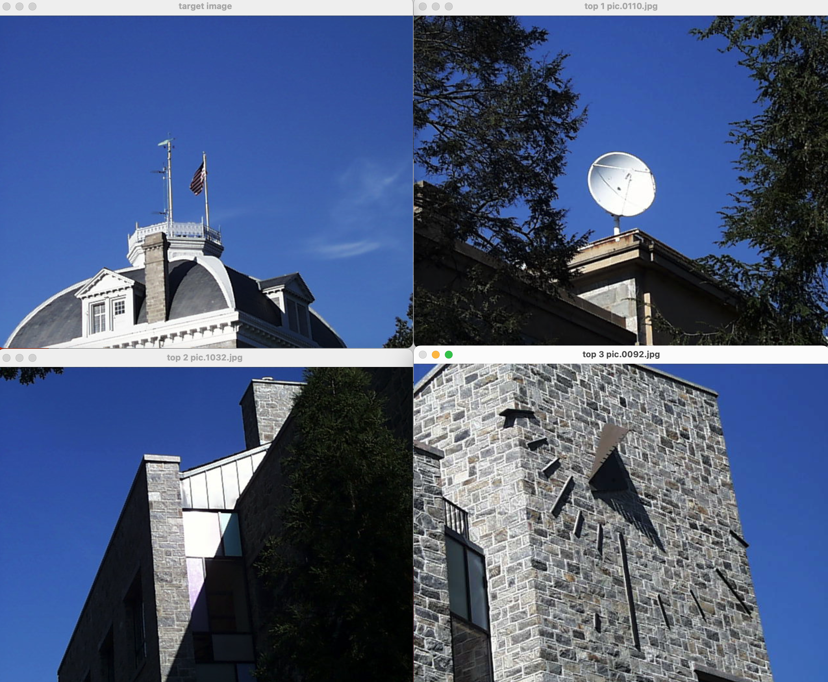

**Multi-Histogram Matching**

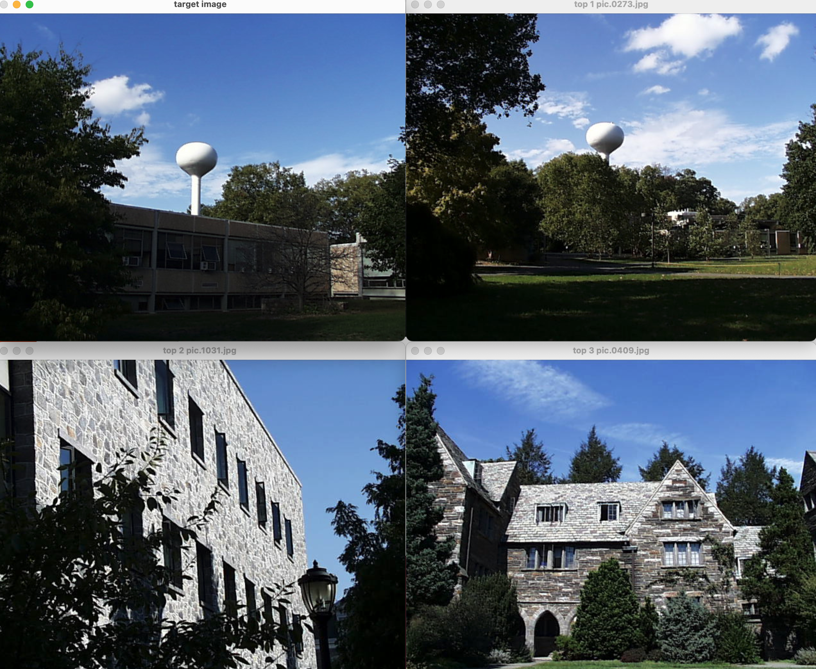

The above images are required results3. These results for query pic.0274 were obtained with two RGB histograms, representing the top and bottom halves of the image, using 8 bins for each of RGB and histogram intersection as the distance metric.

**Texture Matching**

The following images are required result4. This is implemented by calculating the Sobel magnitude image and use a histogram of gradient magnitudes as your texture feature.

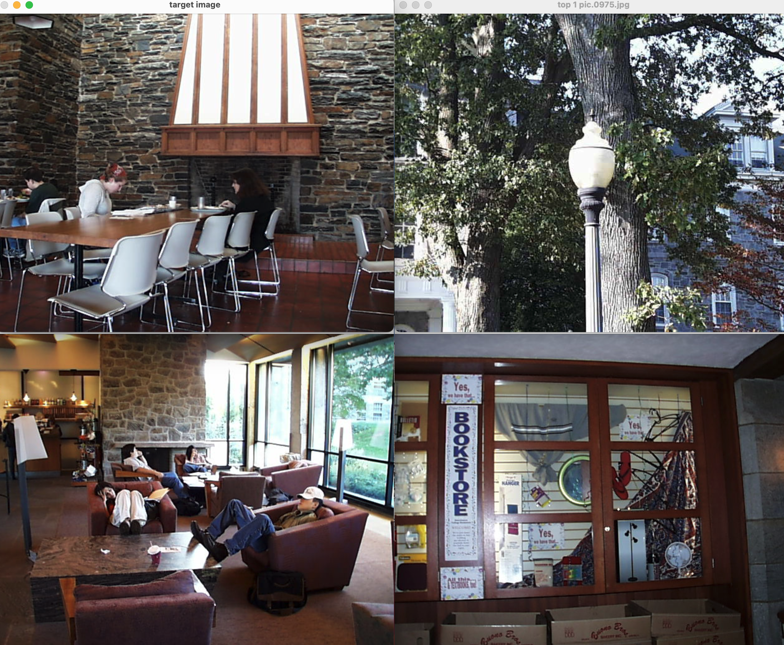

**Custom Extension - HSV - pic.0113.jpg & pic.0333.jpg**

The custom extension I choose is to calculate HSV metrics and using this to compare/match images. The following are 2 sets of results.

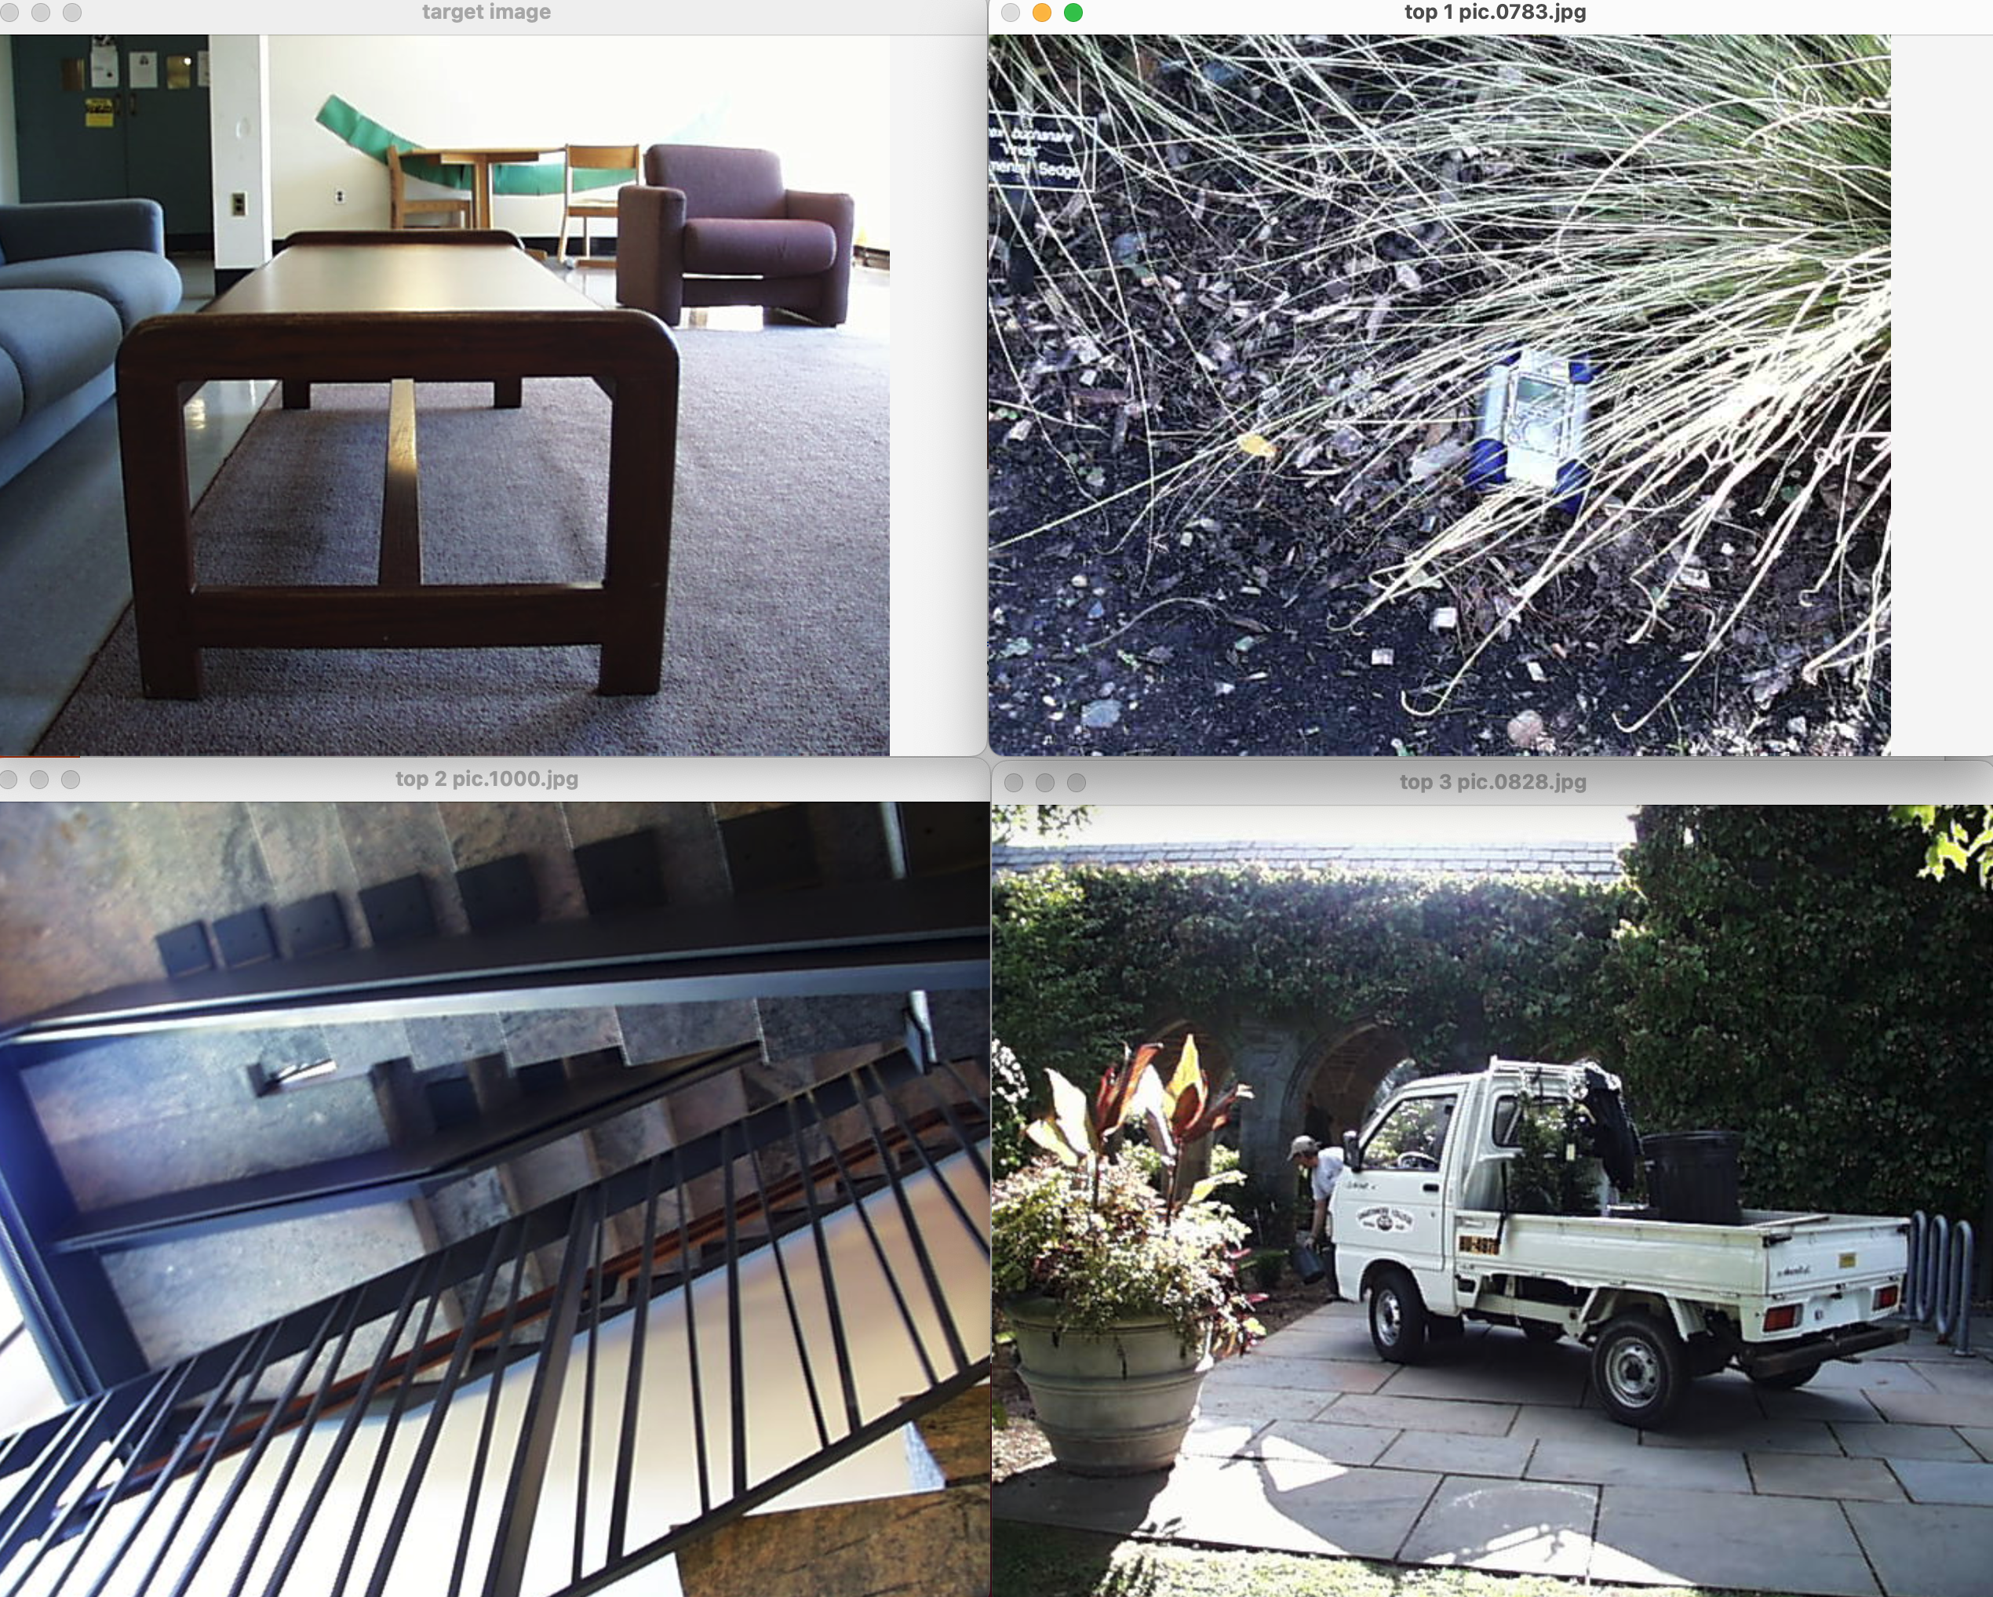

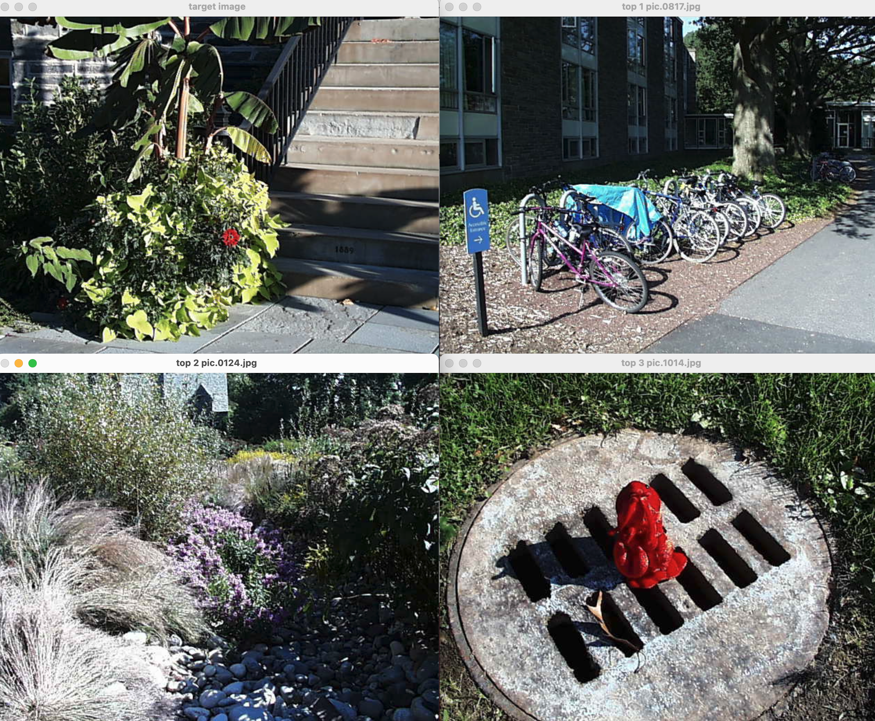

**Key Take-Away**

The takeaway for this project is very straightforward. Through the training of image matching, I clearly understand the logic of image pixel processing. That is, how to obtain data from pictures and quantify the data to obtain metrics. Then use the distance function to express the similarity of the pictures.